
User Manual for the Virtual Machine Management System
CSCI363: Cloud Computing and Networking-2025FALL

Rawan Alghobashy 231000897
Farida Abdelmonem 231000032
Habiba Khaled 231000040
Farah Darwish 231000063

Introduction
The Virtual Machine Management System is a user-friendly application designed to simplify the management of virtual machines and containers using QEMU and Docker. It provides comprehensive instructions for using the system, explaining each feature and its correct usage. The system provides an intuitive button-based interface with a log output area to display system messages and operation results.
This manual explains how to set up and use the GUI application, covering each feature as described in the project objectives.

Prerequisites
- Install Docker on your system.
- Install QEMU on your system.
- Python 3 must be installed.
- An Ubuntu ISO file (e.g., ubuntu-20.04.6-desktop-amd64.iso) for VM testing
- Required Python libraries: docker, os, tkinter, tk, threading, subprocess

GUI Interface

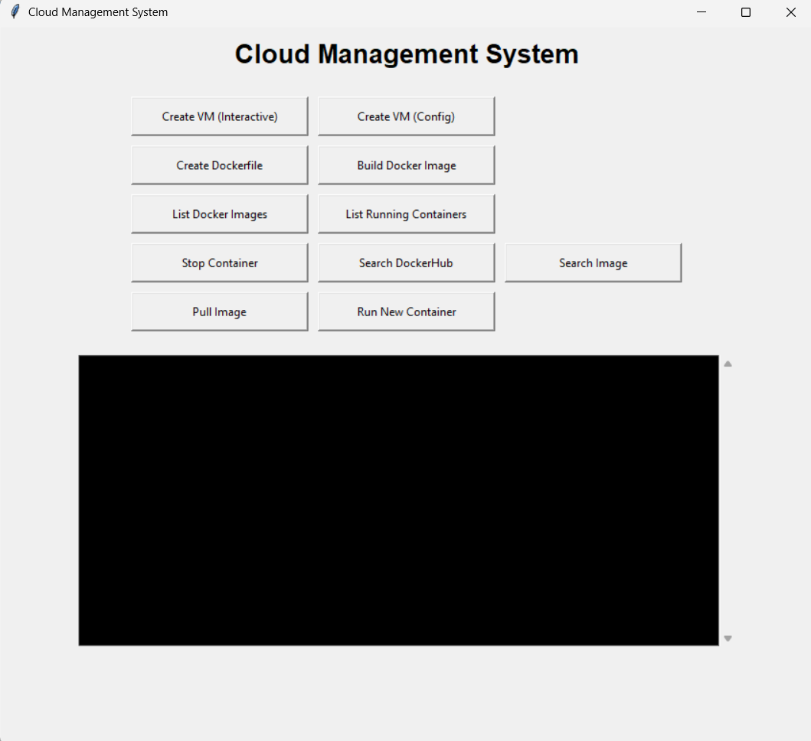

Features and Usage

1. Create Virtual Machine
Purpose: Create and launch a virtual machine using QEMU with specified configuration.
Steps:
- Click the 1. Create Virtual Machine button.
- The system prompts for configuration (interactive or JSON file, as implemented).
- Enter required parameters (CPU, RAM, disk size, ISO path).
- The VM launches in a QEMU window.
- Close the QEMU window to return.

2. Create Dockerfile
Purpose: Create a Dockerfile for Docker images.
Steps:
- Click the 2. Create Dockerfile button.
- Input the Dockerfile contents line by line (end with a specific terminator if prompted).
- The file is saved, and success is logged in the output area.

3. Build Docker Image
Purpose: Build a Docker image from a Dockerfile.
Steps:
- Click the 3. Build Docker Image button.
- Enter the image name and tag.
- Build progress and success/failure are displayed in the log area.

4. List Docker Images
Purpose: List all local Docker images.
Steps:
- Click the 4. List Docker Images button.
- All available local images are displayed in the log output area.

5. List Running Containers
Purpose: Display all currently running Docker containers.
Steps:
- Click the 5. List Running Containers button.
- Running containers (ID, image, status, etc.) are shown in the log area.

6. Stop Container
Purpose: Stop a specific running Docker container.
Steps:
- Click the 6. Stop Container button.
- Enter the container ID or name when prompted.
- The container is stopped, and confirmation appears in the log.

7. Search Local Images
Purpose: Search for a local Docker image by name.
Steps:
- Click the 7. Search Local Images button.
- Enter the search term.
- Matching local images are displayed in the log area.

8. Search DockerHub
Purpose: Search for images on Docker Hub.
Steps:
- Click the 8. Search DockerHub button.
- Enter the image name.
- Search results from Docker Hub are displayed in the log area.
9. Pull Image
Purpose: Download an image from Docker Hub.
Steps:
- Click the 9. Pull Image button.
- Enter the image name and tag (e.g., nginx:latest).
- Pull progress and success are logged in the output area.
- Run Container
Purpose: Run the container created
Steps:
- Click the Run Container button.
- Enter the image name

Log Output Area
- All operations, results, errors, and status messages appear in the black log area at the bottom.
- Successful actions are confirmed with clear messages.

Common Issues and Solutions
- Docker operations fail: Ensure Docker Desktop is open and "Engine running".
- VM not launching properly: Verify QEMU installation and ISO/disk paths.
- No output in log: Check Docker/QEMU are running and paths are correct.

